MIS 6326-Group Project

Hotel Booking Database Management System

Professor: Hakki Cankaya

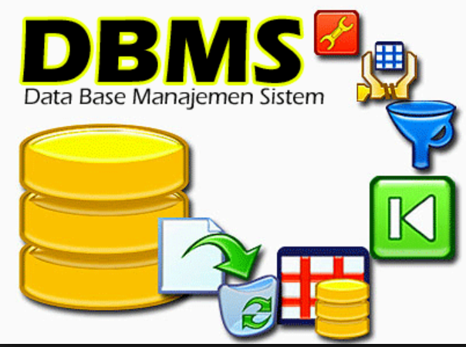

*“We'll leave the light on for you.”*

Project By:

* Nikita Gorathe

Table of Contents

|  |  |
| --- | --- |
| Section Title | Page(s) |
| 1. Part 1 | 2-3 |
| 1. Abstract | 2 |
| 1. Introduction | 2 |
| 1. Similar Database | 3 |
| 2. Part 2 | 4-5 |
| 1. ER-Diagram | 6 |
| 1. Tables | 6-7 |
| 3. Part 3 | 8 |
| 1. Functional Dependencies | 8-9 |
| 1. Normalized ER-Diagram | 9 |
| 1. Views | 10-14 |
| 1. Conclusion | 15 |
| 4. Appendix | 16 |
| 1. Create Table SQL Queries | 16-18 |
| 1. Sample Data SQL Queries | 18-20 |
| 5. References | 21 |

1. **PART 1**

**Abstract**

Our main goal is to create a hypothetical booking database for Studio 6 Motel in Richardson located at 12301 N Central Expy, Dallas, TX 75243. This motel is an old relic off 75 in the northern Dallas metroplex and was chosen based on its diminished appearance and perceived misguided investment. G6 (Parent company) mission is *“to build on the iconic heritage of our brands — Motel 6 and Studio 6 — to become the universally recognized leader in economy lodging. We operate our business with the drive and creativity of an entrepreneur, guided by a heart that's dedicated to hospitality and service.”[1]*

We aim to develop a system that enables customers easy access to information and reservations, thereby enhancing the profit margin for Studio 6 in the future. With the advancement in internet and technology, traveling has increased significantly. Consequently, the demand for hotels has also increased and it is more important than ever to have an efficient, accurate and expedient management system. Hence, we decided to delve further into this topic and develop a reliable, efficient and potentially a cloud-based hotel management system with new features and latest technology which will benefit Studio 6 in numerous ways. For example, it will help the managers to operate 24/7 with complete flexibility. Moreover, there will be no need to hire an IT expert, thus saving hotel’s overall annual expenditure.

**Introduction**

Conceptually, the database should include a table Hotel which describes attributes such as BRANCH_NO, LOCATION, and NO_OF_ROOMS. The database should also include tables such as Reservation which describes attributes like RESERVATION_ID, DATE_CHECKIN, DATE_CHECKOUT, GUEST_ID, and ROOM_ID. The database should include a table Room which describes attributes such as ROOM_ID, ROOM_TYPE, STATUS, PRICE, GUEST_ID, and BRANCH_NO. The database should include table such as Employees which describes attributes such as EMPLOYEE_ID, F_NAME, L_NAME, PHONE, POSITION, SALARY, DOB, SEX and BRANCH_NO. The database should include table such as guest which describes attributes such as GUEST_ID, F_NAME, L_NAME, ADDRESS, PHONE, and DL_ID. We will be using Microsoft SQL Server to implement the database.

**Similar Database**

Similar to this some other database management system examples exists such as a Car Rental Service where we have car rental processing’s instead of hotel room bookings. Car Rental system comprises of a Rental office which owns different cars which are provided on rent as per the user request. When a particular request is made, a reservation_id is generated for that request and assigned to the customer. While renting the car some of the customer details are also taken up so as to confirm the reservation. Apart from booking, they also maintain details of the employees working at the office.

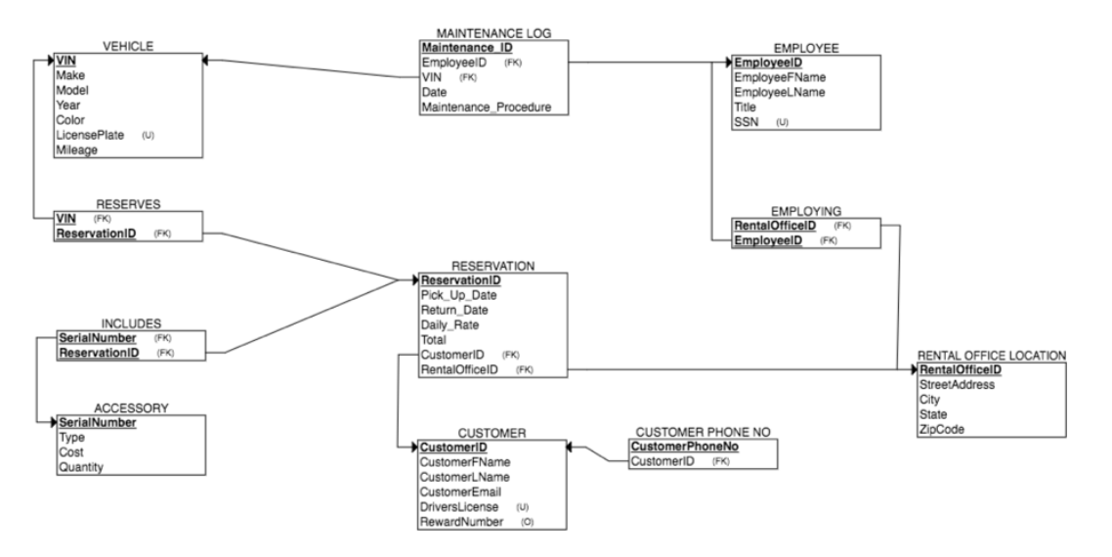Car renting Entity Relationship Diagram[2]

1. **PART 2**

**Entity Relationship Diagram[3]**

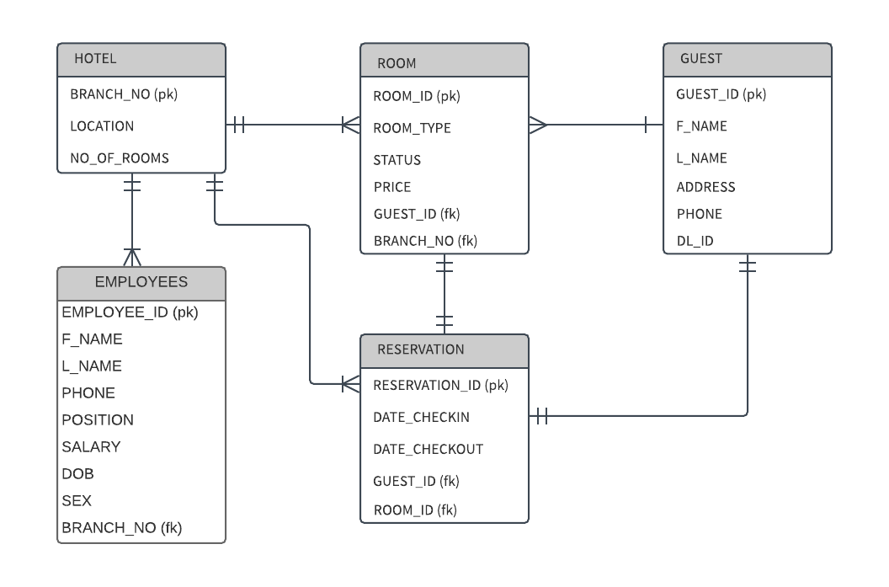

This was our initial Entity Relationship Diagram.

**Tables**

i. Hotel

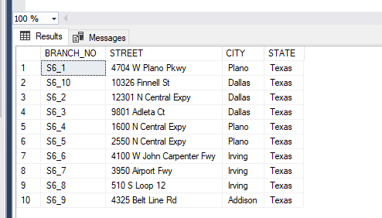

ii. Guest

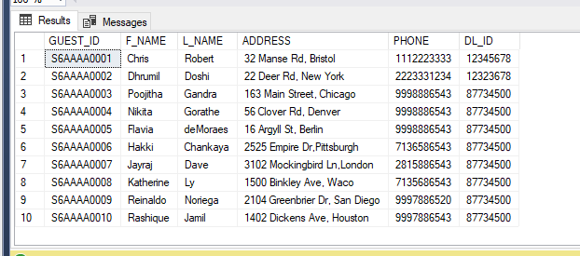

iii. Room:

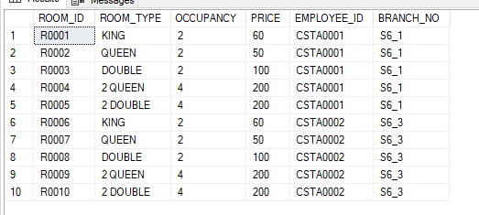

iv. Employees:

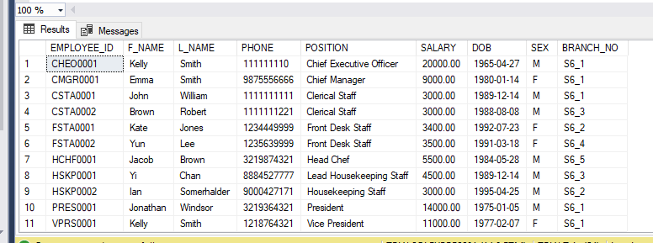

v. Room Service

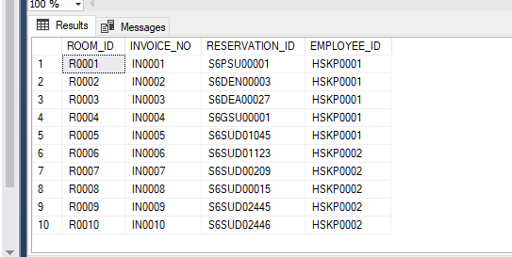

vi. Housekeeping:

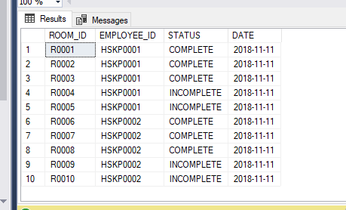

vii. Feedback:

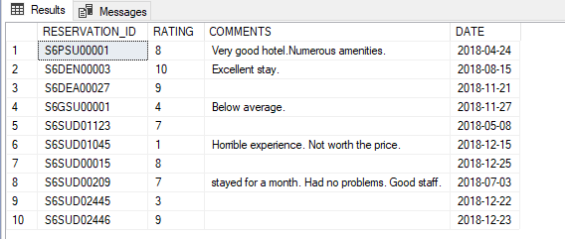

viii. Reservation:

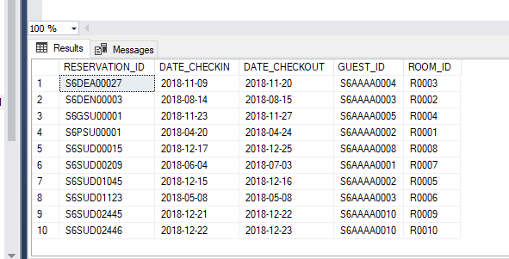

ix. Invoice:

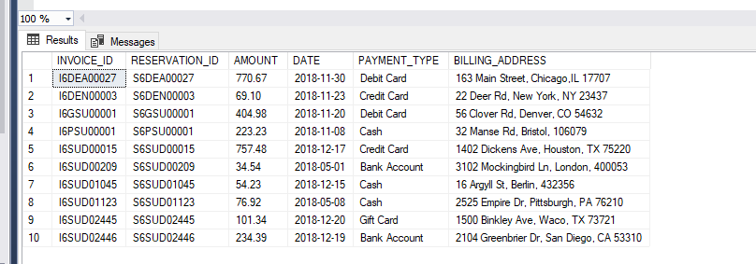

1. **PART 3**
2. **APPENDIX**

**Create Table SQL Queries**

*Hotel*

CREATE TABLE HOTEL (

BRANCH_NO VARCHAR(10) NOT NULL PRIMARY KEY,

STREET VARCHAR(80) NOT NULL,

CITY VARCHAR(80) NOT NULL,

STATE VARCHAR(80) NOT NULL,

);

*Guest*

CREATE TABLE GUEST (

GUEST_ID VARCHAR(10) NOT NULL PRIMARY KEY,

F_NAME VARCHAR(25) NOT NULL,

L_NAME VARCHAR(25) NOT NULL,

ADDRESS    VARCHAR(50)  NOT NULL,

PHONE VARCHAR(10) NOT NULL,

DL_ID VARCHAR(8)  NOT NULL

);

*Room*

CREATE TABLE ROOM (

ROOM_ID VARCHAR(10) NOT NULL PRIMARY KEY,

ROOM_TYPE VARCHAR(35) NOT NULL,

OCCUPANCY INT NOT NULL ,

PRICE   INT NOT NULL,

EMPLOYEE_ID         VARCHAR(10),

BRANCH_NO             VARCHAR(10) NOT NULL,

FOREIGN KEY (EMPLOYEE_ID) REFERENCES EMPLOYEE,

FOREIGN KEY (BRANCH_NO) REFERENCES HOTEL,

);

*Employees*

CREATE TABLE EMPLOYEES(

EMPLOYEE_ID VARCHAR(10) PRIMARY KEY,

F_NAME VARCHAR(25) NOT NULL,

L_NAME VARCHAR(25) NOT NULL,

PHONE VARCHAR(10) NOT NULL,

POSITION VARCHAR(25) NOT NULL,

SALARY DECIMAL(9,2) NOT NULL,

DOB DATE NOT NULL,

SEX VARCHAR(1) NOT NULL,

BRANCH_NO VARCHAR(10) NOT NULL,

FOREIGN KEY(BRANCH_NO) REFERENCES HOTEL

);

*Room Service*

CREATE TABLE ROOM_SERVICE(

ROOM_ID VARCHAR(10) NOT NULL,

INVOICE_NO VARCHAR(10)  PRIMARY KEY,

RESERVATION_ID VARCHAR(10) NOT NULL,

EMPLOYEE_ID VARCHAR(10) NOT NULL,

FOREIGN KEY (EMPLOYEE_ID) REFERENCES EMPLOYEES,

FOREIGN KEY (ROOM_ID) REFERENCES ROOM,

FOREIGN KEY (RESERVATION_ID) REFERENCES RESERVATION

);

*Housekeeping*

CREATE TABLE HOUSEKEEPING(

ROOM_ID VARCHAR(10),

EMPLOYEE_ID VARCHAR(10),

STATUS VARCHAR(15),

DATE DATE NOT NULL,

FOREIGN KEY(ROOM_ID) REFERENCES ROOM,

FOREIGN KEY (EMPLOYEE_ID) REFERENCES EMPLOYEE,

CHECK(STATUS = 'COMPLETE' or STATUS = 'INCOMPLETE')

);

*Feedback*

CREATE TABLE FEEDBACK(

RESERVATION_ID VARCHAR(10) ,

RATING INT CHECK( RATING  between 1 and 10),

COMMENTS VARCHAR(200),

DATE DATE NOT NULL,

FOREIGN KEY (RESERVATION_ID) REFERENCES RESERVATION

);

*Reservation*

CREATE TABLE RESERVATION (

RESERVATION_ID VARCHAR(10) PRIMARY KEY,

DATE_CHECKIN DATE NOT NULL,

DATE_CHECKOUT DATE NOT NULL,

GUEST_ID         VARCHAR(10) NOT NULL,

ROOM_ID                  VARCHAR(10) NOT NULL,

FOREIGN KEY (GUEST_ID) REFERENCES GUEST,

FOREIGN KEY (ROOM_ID) REFERENCES ROOM

);

*Invoice*

CREATE TABLE INVOICE(

INVOICE_ID VARCHAR(10) PRIMARY KEY,

RESERVATION_ID VARCHAR(10) NOT NULL,

AMOUNT DECIMAL (5,2) NOT NULL,

DATE DATE NOT NULL,

PAYMENT_TYPE VARCHAR(20) NOT NULL,

BILLING_ADDRESS VARCHAR(80) NOT NULL,

FOREIGN KEY (RESERVATION_ID) REFERENCES RESERVATION

);

**Sample Data SQL Queries**

*Values into Hotel:*

INSERT INTO HOTEL VALUES('S6_1','4704 W Plano Pkwy','Plano','Texas');

INSERT INTO HOTEL VALUES('S6_2','12301 N Central Expy','Dallas','Texas');

INSERT INTO HOTEL VALUES('S6_3','9801 Adleta Ct','Dallas','Texas');

INSERT INTO HOTEL VALUES('S6_4','1600 N Central Expy','Plano','Texas');

INSERT INTO HOTEL VALUES('S6_5','2550 N Central Expy','Plano','Texas');

INSERT INTO HOTEL VALUES('S6_6','4100 W John Carpenter Fwy','Irving','Texas');

INSERT INTO HOTEL VALUES('S6_7','3950 Airport Fwy','Irving','Texas');

INSERT INTO HOTEL VALUES('S6_8','510 S Loop 12','Irving','Texas');

INSERT INTO HOTEL VALUES('S6_9','4325 Belt Line Rd','Addison','Texas');

INSERT INTO HOTEL VALUES('S6_10','10326 Finnell St','Dallas','Texas');

*Values into Room:*

INSERT INTO ROOM VALUES('R0001','KING',2,60,'CSTA0001','S6_1');

INSERT INTO ROOM VALUES('R0002','QUEEN',2,50,'CSTA0001','S6_1');

INSERT INTO ROOM VALUES('R0003','DOUBLE',2,100,'CSTA0001','S6_1');

INSERT INTO ROOM VALUES('R0004','2 QUEEN',4,200,'CSTA0001','S6_1');

INSERT INTO ROOM VALUES('R0005','2 DOUBLE',4,200,'CSTA0001','S6_1');

INSERT INTO ROOM VALUES('R0006','KING',2,60,'CSTA0002','S6_3');

INSERT INTO ROOM VALUES('R0007','QUEEN',2,50,'CSTA0002','S6_3');

INSERT INTO ROOM VALUES('R0008','DOUBLE',2,100,'CSTA0002','S6_3');

INSERT INTO ROOM VALUES('R0009','2 QUEEN',4,200,'CSTA0002','S6_3');

INSERT INTO ROOM VALUES('R0010','2 DOUBLE',4,200,'CSTA0002','S6_3');

*Values into Guest:*

INSERT INTO GUEST VALUES(‘S6AAAA0001’, ‘Chris’,’Robert’, ‘32 Manse Rd, Bristol’, 1118723333,12345678);

INSERT INTO GUEST VALUES(‘S6AAAA0002’, ‘Dhrumil’,’Doshi’, ‘22 Deer Rd, New York’, 2363331234,12323678);

INSERT INTO GUEST VALUES(‘S6AAAA0003’, ‘Poojitha’,’Gandra’, ‘163 Main Street, Chicago’, 9998986543,87734500);

INSERT INTO GUEST VALUES(‘S6AAAA0004’, ‘Nikita’,’Gorathe’, ‘56 Clover Rd, Denver’, 9368886543,87734500);

INSERT INTO GUEST VALUES(‘S6AAAA0005’, ‘Flavia’,’deMoraes’, ‘16 Argyll St, Berlin’, 9920886543,87734500);

INSERT INTO GUEST VALUES(‘S6AAAA0006’, ‘Hakki’,’Chankaya’, ‘2525 Empire Dr, Pittsburgh’, 7136586543,87734500);

INSERT INTO GUEST VALUES(‘S6AAAA0007’, ‘Jayraj’,’Dave’, ‘3102 Mockingbird Ln, London’, 2815886543,87734500);

INSERT INTO GUEST VALUES(‘S6AAAA0008’, ‘Rashique’,’Jamil’, ‘1402 Dickens Ave, Houston’, 9997886543,87734500);

INSERT INTO GUEST VALUES(‘S6AAAA0009’, ‘Katherine’,’Ly’, ‘1500 Binkley Ave, Waco’, 7135686543,87734500);

INSERT INTO GUEST VALUES(‘S6AAAA0010’, ‘Reinaldo’,’Noriega’, ‘2104 Greenbrier Dr, San Diego’, 9997886520,87734500);

*Values into Employees:*

INSERT INTO EMPLOYEES VALUES(‘CSTA0001’, ‘John’, ‘William’, 1111111111, ‘Clerical Staff’, 3000,’1989-12-14’, ‘M’, ‘S6_1’);

INSERT INTO EMPLOYEES VALUES(‘CSTA0002’, ‘Brown’, ‘Robert’, 1111111221, ‘Clerical Staff’, 3000,’1988-08-08’, ‘M’, ‘S6_3’);

INSERT INTO EMPLOYEES VALUES(‘FSTA0002’, ‘Yun’, ‘Lee’,1235639999, ‘Front Desk Staff’, 3500,’1991-03-18’, ‘F’, ‘S6_4’);

INSERT INTO EMPLOYEES VALUES(‘FSTA0001’, ‘Kate’, ‘Jones’,1234449999, ‘Front Desk Staff’, 3400,’1992-07-23’, ‘F’, ‘S6_2’);

INSERT INTO EMPLOYEES VALUES(‘CMGR0001’, ‘Emma’,  ‘Smith’, 9875556666, ‘Chief Manager’, 9000,’1980-01-14’, ‘F’, ‘S6_1’);

INSERT INTO EMPLOYEES VALUES(‘HSKP0001’, ‘Yi’, ‘Chan’, 8884527777, ‘Lead Housekeeping Staff’, 4500,’1989-12-14’, ‘M’, ‘S6_3’);

INSERT INTO EMPLOYEES VALUES(‘HCHF0001’, ‘Jacob’, ‘Brown’, 3219874321, ‘Head Chef’, 5500,’1984-05-28’, ‘M’, ‘S6_5’);

INSERT INTO EMPLOYEES VALUES(‘PRES0001’, ‘Jonathan’, ‘Windsor’, 3219364321, 'President’, 14000,’1975-01-05’, ‘M’, ‘S6_1’);

INSERT INTO EMPLOYEES VALUES(‘VPRS0001’, ‘Kelly’, ‘Smith’, 1218764321, 'Vice President’, 11000,’1977-02-07’, ‘F’, ‘S6_1’);

INSERT INTO EMPLOYEES VALUES(‘CHEO0001’, ‘Kelly’, ‘Smith’, 111111110, 'Chief Executive Officer’, 20000,’1965-04-27’, ‘M’, ‘S6_1’);

*Values into Room Service:*

INSERT INTO ROOM_SERVICE VALUES('R0001','IN0001','S6PSU00001','HSKP0001');  
INSERT INTO ROOM_SERVICE VALUES('R0002','IN0002','S6DEN00003','HSKP0001');  
INSERT INTO ROOM_SERVICE VALUES('R0003','IN0003','S6DEA00027','HSKP0001');  
INSERT INTO ROOM_SERVICE VALUES('R0004','IN0004','S6GSU00001','HSKP0001');  
INSERT INTO ROOM_SERVICE VALUES('R0005','IN0005','S6SUD01045','HSKP0001');  
INSERT INTO ROOM_SERVICE VALUES('R0006','IN0006','S6SUD01123','HSKP0002');  
INSERT INTO ROOM_SERVICE VALUES('R0007','IN0007','S6SUD00209','HSKP0002');  
INSERT INTO ROOM_SERVICE VALUES('R0008','IN0008','S6SUD00015','HSKP0002');  
INSERT INTO ROOM_SERVICE VALUES('R0009','IN0009','S6SUD02445','HSKP0002');  
INSERT INTO ROOM_SERVICE VALUES('R0010','IN0010','S6SUD02446','HSKP0002');

*Values into Housekeeping:*

INSERT INTO HOUSEKEEPING VALUES('R0001','HSKP0001','COMPLETE','11-11-2018');

INSERT INTO HOUSEKEEPING VALUES('R0002','HSKP0001','COMPLETE','11-11-2018');

INSERT INTO HOUSEKEEPING VALUES('R0003','HSKP0001','COMPLETE','11-11-2018');

INSERT INTO HOUSEKEEPING VALUES('R0004','HSKP0001','INCOMPLETE','11-11-2018');

INSERT INTO HOUSEKEEPING VALUES('R0005','HSKP0001','INCOMPLETE','11-11-2018');

INSERT INTO HOUSEKEEPING VALUES('R0006','HSKP0002','COMPLETE','11-11-2018');

INSERT INTO HOUSEKEEPING VALUES('R0007','HSKP0002','COMPLETE','11-11-2018');

INSERT INTO HOUSEKEEPING VALUES('R0008','HSKP0002','COMPLETE','11-11-2018');

INSERT INTO HOUSEKEEPING VALUES('R0009','HSKP0002','INCOMPLETE','11-11-2018');

INSERT INTO HOUSEKEEPING VALUES('R0010','HSKP0002','INCOMPLETE','11-11-2018');

*Value into Feedback:*

INSERT INTO FEEDBACK VALUES('S6PSU00001',8,'Very good hotel. Numerous amenities.','2018-04-24');

INSERT INTO FEEDBACK VALUES('S6DEN00003',10,'Excellent stay.','2018-08-15');

INSERT INTO FEEDBACK VALUES('S6DEA00027',9,'','2018-11-21');

INSERT INTO FEEDBACK VALUES('S6GSU00001',4,'Below average.','2018-11-27');

INSERT INTO FEEDBACK VALUES('S6SUD01123',7,'','2018-05-08');

INSERT INTO FEEDBACK VALUES('S6SUD01045',1,'Horrible experience. Not worth the price.','2018-12-15');

INSERT INTO FEEDBACK VALUES('S6SUD00015',8,'','2018-12-25');

INSERT INTO FEEDBACK VALUES('S6SUD00209',7,'stayed for a month. Had no problems. Good staff.','2018-07-03');

INSERT INTO FEEDBACK VALUES('S6SUD02445',3,'','2018-12-22');

INSERT INTO FEEDBACK VALUES('S6SUD02446',9,'','2018-12-23');

*Values into Reservation:*

INSERT INTO RESERVATION VALUES('S6PSU00001','2018-04-20','2018-04-24','S6AAAA0002','R0001');

INSERT INTO RESERVATION VALUES('S6DEN00003','2018-08-14','2018-08-15','S6AAAA0003','R0002');

INSERT INTO RESERVATION VALUES('S6DEA00027','2018-11-09','2018-11-20','S6AAAA0004','R0003');

INSERT INTO RESERVATION VALUES('S6GSU00001','2018-11-23','2018-11-27','S6AAAA0005','R0004');

INSERT INTO RESERVATION VALUES('S6SUD01045','2018-12-15','2018-12-16','S6AAAA0002','R0005');

INSERT INTO RESERVATION VALUES('S6SUD01123','2018-05-08','2018-05-08','S6AAAA0003','R0006');

INSERT INTO RESERVATION VALUES('S6SUD00209','2018-06-04','2018-07-03','S6AAAA0001','R0007');

INSERT INTO RESERVATION VALUES('S6SUD00015','2018-12-17','2018-12-25','S6AAAA0008','R0008');

INSERT INTO RESERVATION VALUES('S6SUD02445','2018-12-21','2018-12-22','S6AAAA0010','R0009');

INSERT INTO RESERVATION VALUES('S6SUD02446','2018-12-22','2018-12-23','S6AAAA0010','R0010');

*Values into invoice:*

INSERT INTO INVOICE VALUES('I6PSU00001','S6PSU00001',223.23,'2018-11-08','Cash','32 Manse Rd, Bristol, 106079');

INSERT INTO INVOICE VALUES('I6DEN00003','S6DEN00003',69.10,'2018-11-23','Credit Card','22 Deer Rd, New York, NY 23437');

INSERT INTO INVOICE VALUES('I6DEA00027','S6DEA00027',770.67,'2018-11-30','Debit Card','163 Main Street, Chicago,IL 17707');

INSERT INTO INVOICE VALUES('I6GSU00001','S6GSU00001',404.98,'2018-11-20','Debit Card','56 Clover Rd, Denver, CO 54632');

INSERT INTO INVOICE VALUES('I6SUD01045','S6SUD01045',54.23,'2018-12-15','Cash','16 Argyll St, Berlin, 432356');

INSERT INTO INVOICE VALUES('I6SUD01123','S6SUD01123',76.92,'2018-05-08','Cash','2525 Empire Dr, Pittsburgh, PA 76210');

INSERT INTO INVOICE VALUES('I6SUD00209','S6SUD00209',34.54,'2018-05-01','Bank Account','3102 Mockingbird Ln, London, 400053');

INSERT INTO INVOICE VALUES('I6SUD00015','S6SUD00015',757.48,'2018-12-17','Credit Card','1402 Dickens Ave, Houston, TX 75220');

INSERT INTO INVOICE VALUES('I6SUD02445','S6SUD02445',101.34,'2018-12-20','Gift Card','1500 Binkley Ave, Waco, TX 73721');

INSERT INTO INVOICE VALUES('I6SUD02446','S6SUD02446',234.39,'2018-12-19','Bank Account','2104 Greenbrier Dr, San Diego, CA 53310');

1. **REFERENCES**

1. Ref: <http://www.g6hospitality.com/about/mission>
2. Ref: <https://www.alexanderjsingleton.com/gwmsist-rental-car-inventory-relational-database-system-research/>
3. Ref: <https://www.lucidchart.com>